Committee member nomination form
This form shall be used for the elected positions shown in blue below:

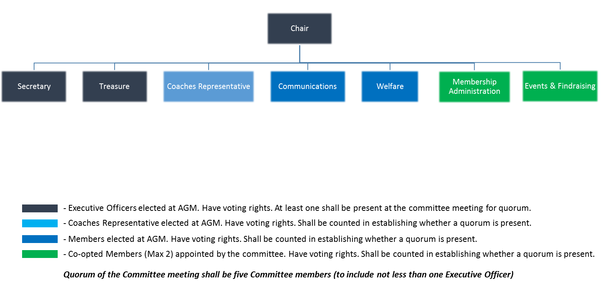
Treasurer
Nominee Name:

For the elected position of:
(Coaches Representative position can only be nominated and seconded by the coaching staff)

Proposed by:

Seconded by:

Signed by the nominee: Date:
(Indicating acceptance of the nomination and the agreement to embrace the roles and responsibilities assigned to the function as shown below)

Roles and Responsibilities of the Elected Officer Function:
Executive Committee Member
Chair
Directing and overriding responsibility for all decisions and actions taken on behalf of the Club, all club members, contractual agreements and finances. Swim 21 compliance and accreditation. Arranging training courses for coaches and committee roles. Coordinating arrangement of new training facilities. Reviewing policies and procedures for consistency and compliance
Secretary
Recording of all decisions, contractual agreements, policies and procedures on behalf of the Club. Production of documentation relating to Swim 21 accreditation. Insurance.
Treasurer
Recording of all financial transactions on behalf of the Club. Ensuring the Club’s financial stability through regular communication with the Committee, arranging annual financial review. Financial planning.

Coach Representative
Representing coach’s views at committee meetings. Acting as liaison point between committee and coaches to ensure mutual support for the benefit of the whole club.

Elected Member
Communications
Coordination of website and social media communication. Coordination of newspaper reports, Preparation of Club internal communication including newsletters and Mailchimp, club promotion and publicity.
Welfare
First line responsibility for Club Welfare encompassing all divers, coaches and parent members. Ensuring adherence to current ASA regulations surrounding equity, welfare and inclusion and communication of relevant policies.

Continues

Co-Opted Members
Administrative Members
Including:
Responsibility for maintenance of Swim England Membership, club records including medical, contact and permission statements. Maintenance of records relating to club administration including code of conduct, course attendance and qualifications. Club kit. Day to day management of Learn to Dive Programme. Arranging Diver of the Month nominations and voting. Coordination of the SwimMark Swim England Kite Mark.

Events and Fundraising
Arranging social events (Christmas and summer social event) for divers and families. Arranging annual Awards Evening. Arranging fundraising tables and food for Christmas Gala and Interclub events. Seeking grant options to support Club activities

